Before coming to Lindsey please complete the online portion of the registration:

- Visit: www.lcisd.org. Choose “Register Online”.

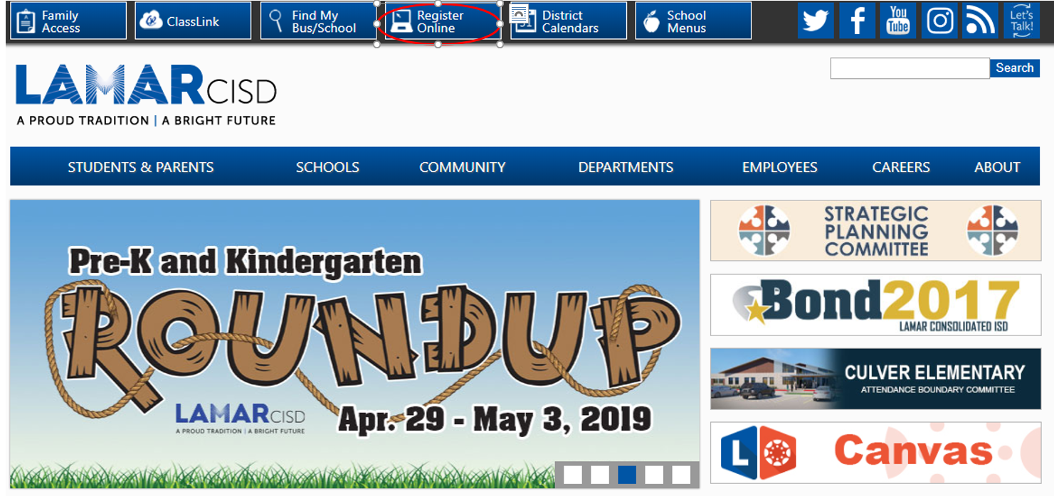

- This will take you to the registration portal. Please choose “Click here to proceed”.

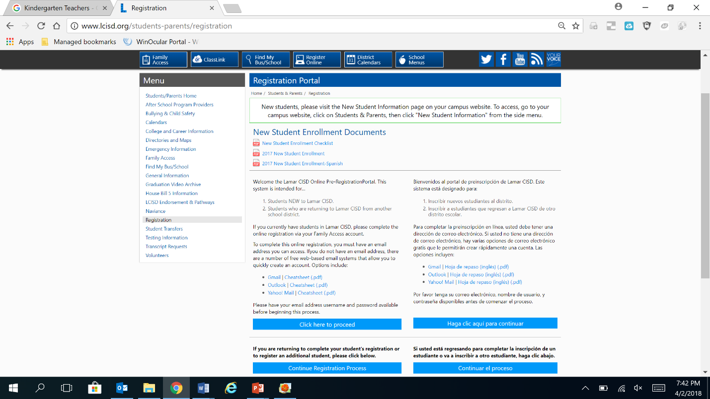

- You will now create a username and password for your Skyward Account. Please complete the requested information and submit your Online Enrollment Account Request.

- After this information is submitted, you will receive an email with your username and password. You will take this information and log back into Skyward.
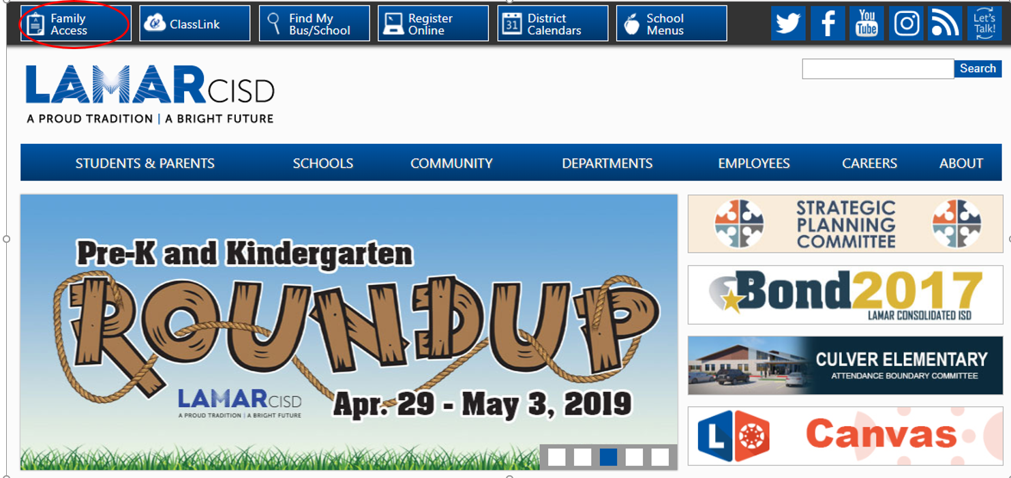

- You will complete several sections that will provide the district with detailed information about your child. After completing all sections of the application, you will submit the application for approval. After submission, you will receive an email, advising you as to what documentation is needed in order to complete your enrollment at the school.

- Please bring in the following documents to Lindsey to complete your enrollment. Please note your registration is not complete until we have copies of all the documents listed below:
- Parent Driver’s License. The address on the license must match the registration address.
- Student Birth Certificate
- Student Social Security Card
- Proof of Residency (which includes water, gas or electric bill, current lease agreement or closing statement)
- Up to date immunization record
- Dual Residency Applications are available in the front office for those parents who are residing with a LCISD resident.

