Opportunities to support LCHS ProGrad Organization:
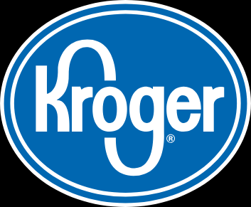Kroger Community Rewards
Kroger is committed to helping our communities grow and prosper. Kroger Community Rewards makes fund-raising easy. After you link our organization to your account, all you have to do is shop at Kroger and swipe your Plus Card!
To get set up, just go to www.Kroger.com
Set up an account, if you don’t have one already
In the Savings & Rewards tab, click on Kroger Community Rewards
Select I’m a Customer, then search for LAMAR CONSOLIDATED H.S. PROJECT GRADUATION Organization Number is: SR409
______________________________________________________________________
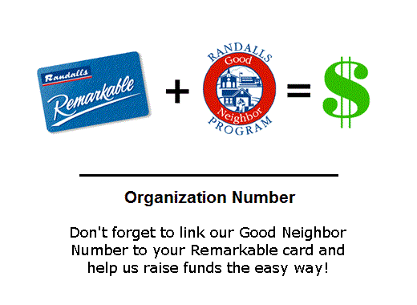Randalls Good Neighbor Program
Randalls believes in working together with customers to support programs that improve the quality of life in the communities we serve. We are committed to assisting non-profit organizations that are important to our customers and their families. After you link our organization to your account, all you have to do it shop at Randalls and swipe your card.

To link your existing Remarkable Card with LCHS ProGrad Organization just go to www.randalls.com to fill out the form or send an email with your Remarkable Card number and the Lamar ProGrad’s Charity # 1986 to: good.neighbor@randalls.com
______________________________________________________________________
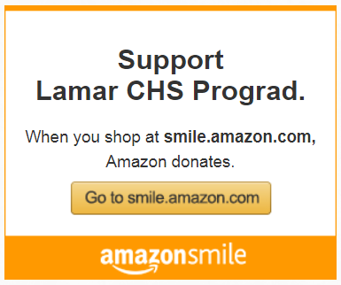 Amazon Smile
- AmazonSmile is the same Amazon you know. Same products, same prices, same service.
- Support your ProGrad organization by starting your shopping at smile.amazon.com
- Select Lamar CHS ProGrad.charity or visit our website http://www.lchsprograd.org/ to go directly into the smile.amazon.com link before you shop

