2013

Geometry PAP

Summer

Prep

Packet



TOPIC: RADICALS & SIMPLIFYING RADICALS
Geometry Class Notes

Radical PARTS:
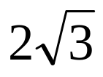
coefficient radicand
radical symbol
**No coefficient means ______________ in front**

SIMPLIFYING:
 When working with simplification of radicals, one must remember basic information about perfect square numbers.

Lets recall/ identify perfect square numbers & square root numbers.

PERFECT SQUARES

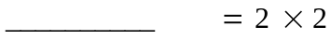
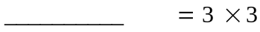
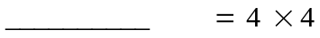
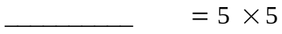
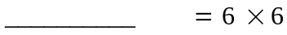
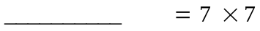
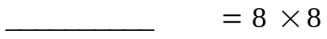
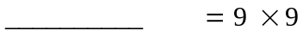
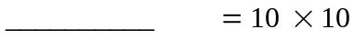
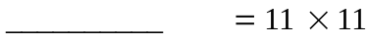
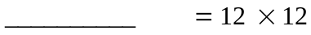
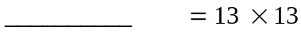
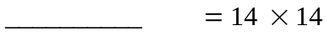
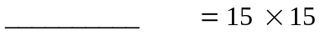

RADICALS (square roots)

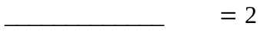
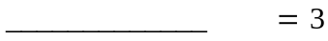
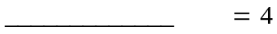
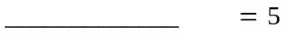
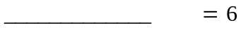
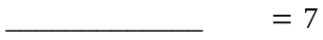
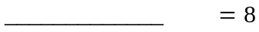
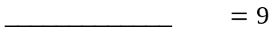
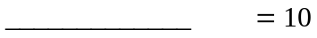
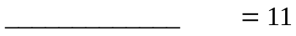
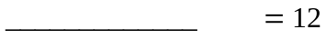
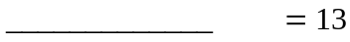
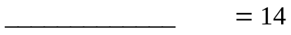
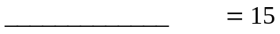

SIMPLIFYING METHOD: FACTORING HIGHEST PERFECT SQUARE (most efficient):

STEP 1: Break number (inside radicand) into 2 ________________, with the first one being the HIGHEST PERFECT _________________;

STEP 2: Pull out the square root number (place it outside the house) and leave the rest inside.

Example: simplify 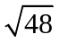. Use factors 16 & 3, not 8 & 6. 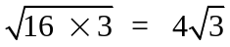
By using HIGHEST PERFECT SQUARE, saves you time and money….. or sorry, just saves you time and effort.

Simplify the following in simplified radical form…NO DECIMALS PLEASE.

1. 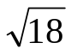 | 2. 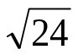 | 3. 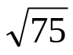
4. 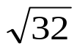 | 5. 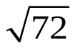 | 6. 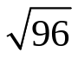
7. 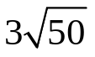 | 8. 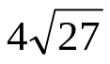 | 9. 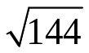
10. 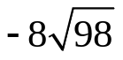 | 11. 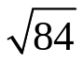 | 12. 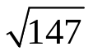

ADDING OR SUBTRACTING:

STEP 1: Must be same radicands in order to add or subtract ( _______________ terms)

NOTE : If radicands are NOT THE SAME, try ____________________ first.

STEP 2: Add or subtract the outside coefficients (leave radicands as is, just like a denominator with fractions

Simplify the following:

1. 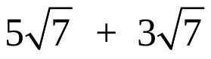 2. 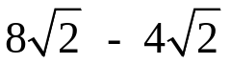 3. 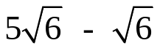

4. 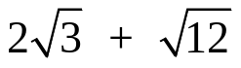 5. 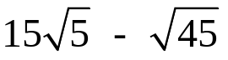

MULTIPLYING AND/OR DIVIDING:

Note: the phrase that pays, “inside to inside, outside to outside” sing it to yourself.

STEP 1: Multiply the ______________ numbers together; then multiply the ___________________ numbers together

STEP 2 : Keep the two parts of the answer separate (outside numbers together; inside numbers together

STEP 3: _________________ the final answer, if needed.

Simplify the following:
1. 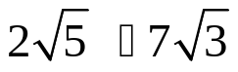 | 2. 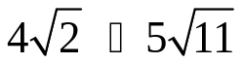 | 3. 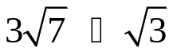
4. 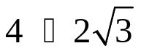 | 5. 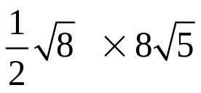 | 6. 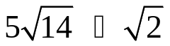
7. 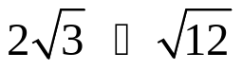 | 8. 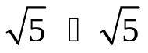 | 9. 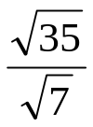
10. 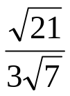 | 11. 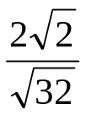 | 12. 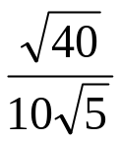

RATIONALIZING (removing radical from denominator)

Note: tactic used to get rid of radical on the bottom of a fraction.

STEP 1: Multiply the ______________ and _______________ by the bottom radical (get rid of radical on bottom).

STEP 2 : Simplify the radical, if needed.

1. 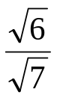 | 2. 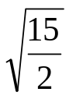 | 3. 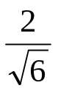

Geometry Name: _____________________
Radical Review Practice #1 Period: ________

Simplify.

- 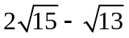 2. 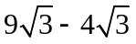 3. 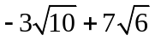

4. 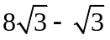 5. 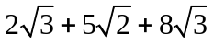 6. 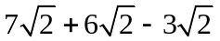

7. 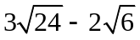 8. 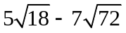 9. 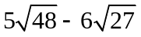

Express each of the following square roots in simplest form. Do not use a calculator.

10. 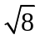 11. 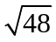 12. 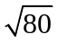

13. 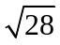 14. 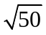 15. 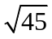

16. 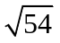 17. 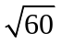 18. 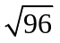

19. 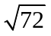 20. 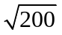 21. 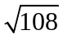

22. 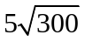 23. 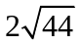 24. 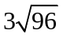

25. 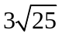 26. 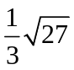 27. 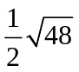

28. 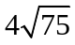 29. 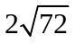 30. 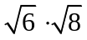

31. 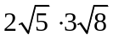 32. 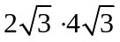 33. 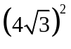

34. 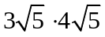 35. 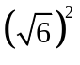 36. 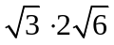

37. 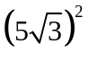 38. 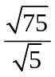 39. 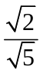

40. 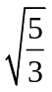 41. 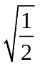 42. 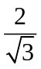

43. 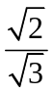 44. 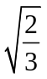 45. 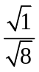

46. 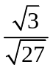 47. 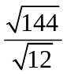 48. 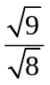

Geometry Name: _____________________
Radical Review Practice #2 Period: ________

Multiplying, Dividing, and Simplifying Radicals

Objective: To simplify products and quotients of radicals.

Simplify. Assume that all variables represent positive real numbers.

1. 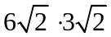 2. 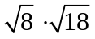 3. 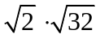

4. 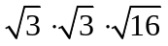 5. 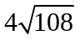 6. 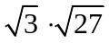

7. 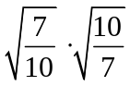 8. 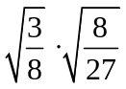 9. 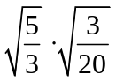

10. 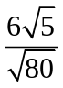 11. 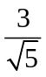 12. 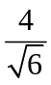

13. 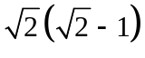 14. 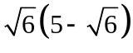 15. 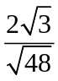

Geometry Name: _____________________
Radical Review Practice #2-con’t Period: ________

Adding and Subtracting Radicals

Objective: To simplify sums and differences of radicals. Simplify.

1. 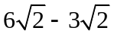 2. 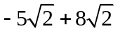 3. 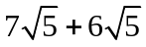

4. 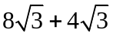 5. 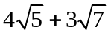 6. 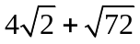

7. 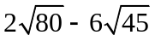 8. 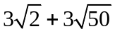 9. 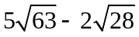

10. 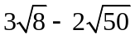 11. 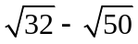 12. 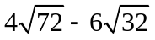

13. 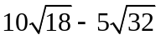 14. 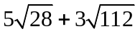 15. 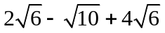

16. 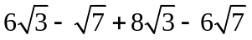 17. 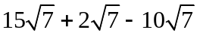 18. 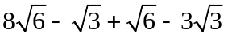

19. 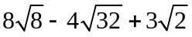 20. 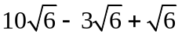 21. 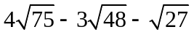

Geometry Name: _____________________
Algebra Review: Linear Equations Period: ________

Do on your own paper and show all work.

I. Find the slope of the line containing each pair of points.
1. (5, 0) and (6, 8) 2. (4, -3) and (6, -4) 3. (-2, -4) and (-9, -7)

II. Find the slope of each line.

4. y = 7 5. x = -4 6. 2x + y = 15 7. x - 2y = 7

III. Find the equation of the line with the given slope through the given point in slope-intercept form.
8. m = 4; (3, 2) 9. m = -2; (4, 7) 10. 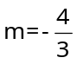; (3, -1)

IV. Find the equation of the line containing the following points in standard form.
11. (2, 6) and (4, 1) 12. (3, 5) and (-5, 3) 13. (-2, -3) and (-4, -6)

V. Write the equation of the line in standard form.

14. The line with x-intercept 4 and y-intercept –5.

15. The line containing (0, 3) and (-2, 0).

VI. Write the equation of the line in point-slope form.

16. The line containing (-3, -2) and (5, 2).

17. The horizontal line passing through (2, 5) and (-3, 5)

VII. Write the equation of the line slope-intercept form.

18. The line containing (3, 1) and (4, 8).

19. The line containing (3, 3) and (-6, 9).

20. The line with slope 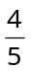 and containing (-1, 7).

Geometry Pre-AP Name: _______________________
Algebra Review: Graphing Lin. Equations WS Period: __________

Graph the following equations. Graph at least three points for each equation on your OWN graph paper.

Point-slope form
1. 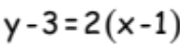 2. 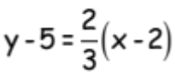 3. 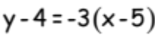

4. 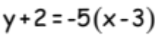 5. 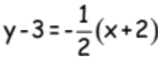 6. 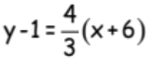

7. 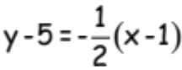 8. 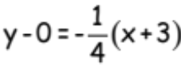 9. 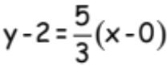

Slope-intercept form
10. 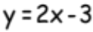 11. 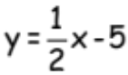 12. 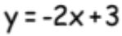

13. 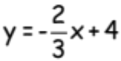 14. 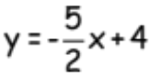 15. 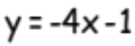

16. 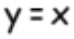 17. 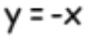 18. 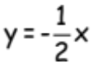

Standard form
19. 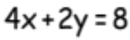 20. 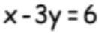 21. 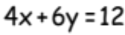

22. 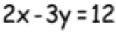 23. 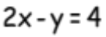 24. 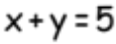

25. 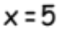 26. 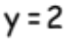 27. 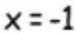

Geometry Pre-AP Name: _______________________
Algebra Review: Solving Equations & Systems Period: __________

Do on your own paper and show all work.
Solve for the variable in each problem.
1. 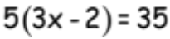 2. 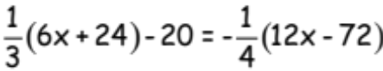 3. 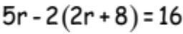

4. 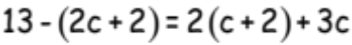 5. 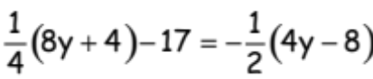 6. 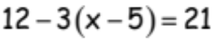

Solve each system of linear equations. You may solve by either substitution or elimination.

7. 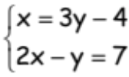 8. 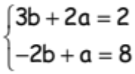 9. 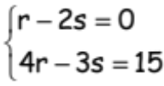

10. 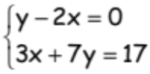 11. 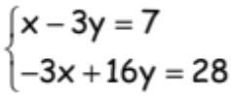 12. 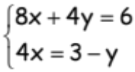

13. 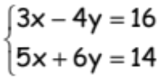 14. 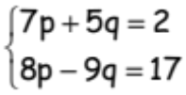 15. 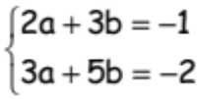

16. 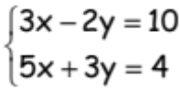 17.

Algebra Review: Polynomials and Factoring WS

Do on your own paper and show your work.
Multiply the following binomials.

1. 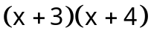 2. 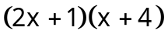 3. 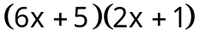

4. 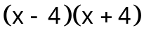 5. 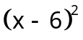 6. 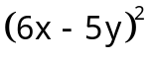

Factor each of the following polynomials.

7. 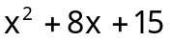 8. 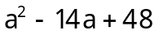 9. 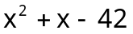

10. 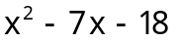 11. 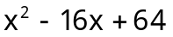 12. 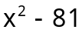

13. 2x² + 9x + 7 14. 5x² + 28x + 15 15. 6x² – 25x + 4

16. 3x² – 23x + 30 17. 2x² – 5x – 12 18. 3x² + 5x - 28

Solve each quadratic equation by the square root property.
19. 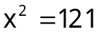 20. 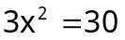 21. 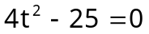

22. 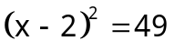 23. 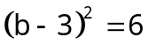 24. 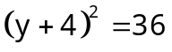

Solve each quadratic equation by factoring.

25. 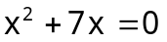 26. 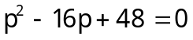 27. 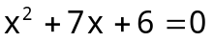

28. 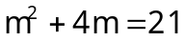 29. 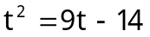 30. 

