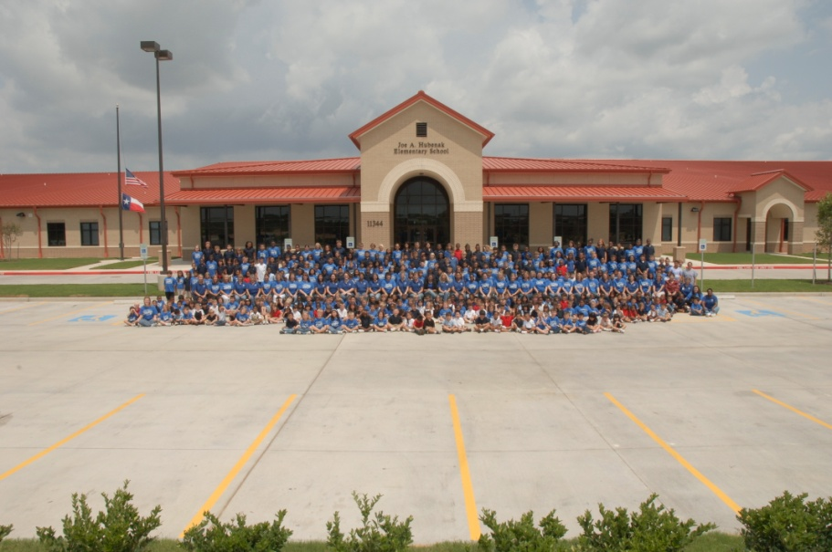

**Hubenak Elementary**

11344 Rancho Bella Pkwy.

Richmond, TX 77406

Phone: 832-223-2900

Fax: 832-223-2901

/JoeHubenakElementary

[@HubenakElementa](https://twitter.com/HubenakElementa)

http://www.lcisd.org/campuses/hubenak/home

<http://www.lcisd.org/campuses/hubenak/home>

**Hubenak Information:**

* Established 2009
* Exemplary 2010, 2011
* Met Standard 2013-2017
* Academic Distinctions: Math, Reading, Science, Top 25% Student Progress, Post-Secondary Readiness
* Husky Mascot
* School colors—royal blue and black
* Student Uniform/Standardized Dress
* Grades PK—5th grade
* Pegasus—employee daycare
* Instructional Specialists-Reading,

Math/Science, ESL

Diane Parks, Principal

[dparks@lcisd.org](mailto:dparks@lcisd.org)

Ernie Bainbridge, Assistant Principal

[ernest.bainbridge@lcisd.org](mailto:ernest.bainbridge@lcisd.org)

Kevin Kracker, Counselor

[kkracker@lcisd.org](mailto:kkracker@lcisd.org)

Sheri Lopez, Instructional Coordinator

[slopez@lcisd.org](mailto:slopez@lcisd.org)

Gloria Pena, Administrative Assistant

[gpena@lcisd.org](mailto:gpena@lcisd.org)

**Hubenak Highlights:**

* Holdsworth Campus Leadership Team
* Technology—Promethean Boards, iPADs, laptops, etc.
* 2018 Recipient of $11,996-LEAF Grants
* Community Service Projects
* No Place for Hate Campus
* Art Club
* Bluebonnet Reading Program: Winning school 2014-2018
* Husky Broadcasting Club
* Library-Maker Space
* Student Council
* Robotics Team
* Run Club
* 4th and 5th Grade Award Winning Choir

*Pulling together to learn today and lead tomorrow because the race for excellence has no finish line.*