This year, Lamar CISD would like to utilize text messaging to communicate important information to our community. To opt in to these messages, parents must log in to the Skyward Family Access Center and add a Text Message Number to their Skylert communication options. To access this option, first click on the “Skylert” menu option inside the Family Access Center.
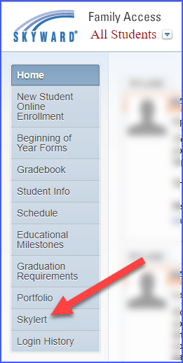
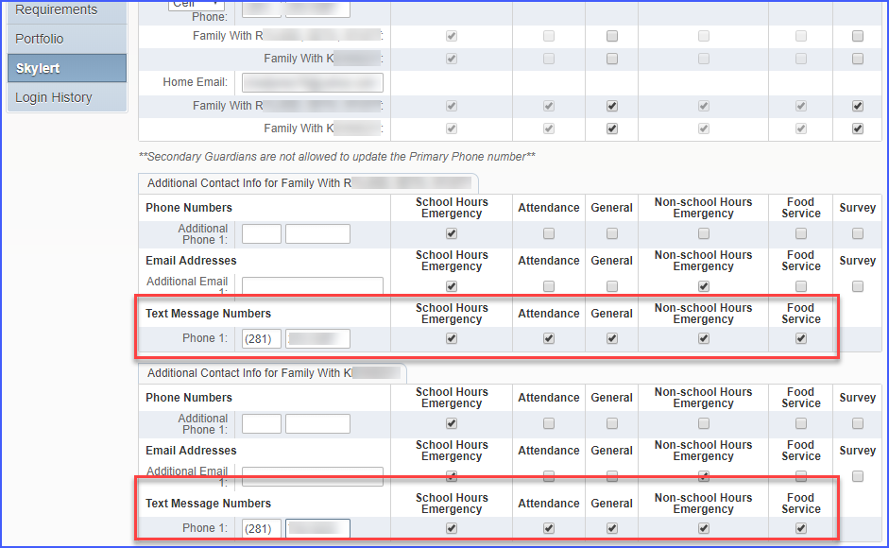
Once on the Skylert communication screen, scroll to the bottom of the page and add a Text Message Number to be associated with your students. You should also select the types of communication you would like to receive via text. You may also add additional contact options in the “Additional Contact Info” area.
After you have made all necessary changes, scroll to the top of the page and click the “Save” button.
