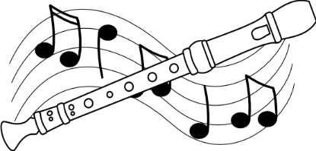

January 21, 2015

It’s time! It’s finally time! The Austin Elementary Recorder Club is about to begin!!!

Recorder Club is open to any 3rd, 4th or 5th grade student that is passing all classes, has good conduct,
and likes to play the recorder. (All students must supply their own recorder.)

All students participating must return a signed permission slip and have made prior transportation
arrangements. Recorder Club will meet once a month, from dismissal time until 4:00. Students picked up late (after 4:15) more than two times will not be able to participate in Recorder Club.

Recorder Club is designed for players of all levels to enjoy playing with one another. Students will pick up music for their skill-level outside of the music room. There will be music for “Beginners” (students that have mastered White thru Orange belt), “Intermediate” (students that have mastered Green thru Purple belt) and “Advanced” (students that have mastered Blue belt and beyond). Students will need to practice their skill-level music prior to RC meetings.

I am really looking forward to hearing our young musicians expand on what they have learned in class! What talented students we have at Austin!

If you have any questions, please feel free to contact me here at school.

Sincerely,

Laura Brown
AES Music Teacher
lbrown@lcisd.org
832-223-1038

Dates for Recorder Club are: Feb. 12th, March 26th, April 9th, May 21st

Recorder Club Permission Slip

Student:_____________________________________________ Grade:________________

Homeroom Teacher: __________________________________________________________

Parent Information:

Mom (h)_________________ (cell) ____________________ (email)____________________

Dad (h)_________________ (cell) ____________________ (email)_____________________

Transportation: (please check)

_____Student will be picked up by: _______________________________ Phone:___________

_____Student will walk home.

_____Student will carpool with ____________________________________________________

Please sign and return

I give permission for my child, ________________________________ to participate in the AES Recorder Club. I understand that choir rehearsals conclude at 4:00, and I have transportation arrangements made prior to the first rehearsal. I understand that if my child is picked up late three times, they will no longer be eligible to participate in Recorder Club.

_______________________________________________ ________________________
Parent/Guardian Signature Date

